**Lab 2.Addressing Technology**

**Objective**

* Understand the Addressing Technologies, including DHCP, NAT and IPv6 transition.

**Topology**

**Address Scheme**

**Inside:**

|  |  |  |  |
| --- | --- | --- | --- |
| Host name | Interface | IPv4/IPv6 address | Memo |
| Switch1 | F0/1 | N/A | VLAN ID = 11 |
| F0/2 | N/A | VLAN ID = 22 |
| F0/3 | N/A | VLAN ID = 88 |
| F0/23~24 | N/A | VLAN ID = All VLANs (trunk) |
| Switch2 | F0/1 | N/A | VLAN ID = 11 |
| F0/2 | N/A | VLAN ID = 22 |
| F0/3 | N/A | VLAN ID = 88 |
| F0/23~24 | N/A | VLAN ID = All VLANs (trunk) |
| Switch3 | F0/1 | N/A | VLAN ID = 101 |
| F0/6 | N/A | VLAN ID = 66 |
| F0/21~24 | N/A | VLAN ID = All VLANs (trunk) |
| Vlan 11 | IPv4: 192.168. 11. 1/24 | SVI |
| Vlan 22 | IPv4: 192.168. 22. 1/24 | SVI |
| Vlan 66 | IPv4: 192.168. 66. 1/24 | SVI |
| Vlan 88 | IPv4: 192.168. 88. 1/24 | SVI |
| Vlan 99 | IPv4: 192.168. 99. 2/24 | SVI |
| Vlan 101 | IPv4: 192.168.101. 2/24 | SVI |
| Switch4 | F0/1 | N/A | VLAN ID = 102 |
| F0/21~24 | N/A | VLAN ID = All VLANs (trunk) |
| Vlan 11 | IPv4: 192.168. 11. 2/24 | SVI |
| Vlan 22 | IPv4: 192.168. 22. 2/24 | SVI |
| Vlan 88 | IPv4: 192.168. 88. 2/24 | SVI |
| Vlan 99 | IPv4: 192.168. 99. 2/24 | SVI |
| Vlan 102 | IPv4: 192.168.102. 2/24 | SVI |
| Switch99 | F0/1 | N/A | VLAN ID = 99 |
| F0/2 | N/A | VLAN ID = 99 |
| F0/3 | N/A | VLAN ID = 99 |
| F0/6 | N/A | VLAN ID = 99 |
| F0/21~24 | N/A | VLAN ID = All VLANs (trunk) |
| Gateway-Router1 | F0/0 | IPv4: 192.168.101. 1/24 | N/A |
| F0/1 | IPv4: 192.168.102. 1/24 | N/A |
| F1/0 | IPv4: 200.200.200. 2/30 | N/A |
| IPv6-Router | F0/0 | IPv6: 2001:2345:6789: 66:: 6/64 | N/A |
| F0/1 | IPv4: 192.168. 66. 6/24 | N/A |
| Router99 | F0/0 | IPv6: 2001:2345:6789: 99:: 6/64 |  |
| F0/1 | IPv4: 192.168. 99. 6/24 |  |
| Teacher-PC1~2 | F0 | IPv4: 192.168. 11.101~199/24 | N/A |
| Student-PC1~2 | F0 | IPv4: 192.168. 22.101~199/24 | N/A |
| Guest-Laptop1~2 | F0 | IPv4: 192.168. 88.101~199/24 | N/A |
| IPv6-PC1~2  IPv6-Laptop |  | IPv6: 2001:2345:6789: 66::?:?:?:?/64 |  |
| Web-Server  FTP Server  DHCP-Server  IPv6-Server | F0  F0  F0  F0 | IPv4: 192.168. 99.101/24  IPv4: 192.168. 99.102/24  IPv4: 192.168. 99.103/24  IPv6: 2001:2345:6789. 99::106/64 | N/A |

**Outside:**

|  |  |  |  |
| --- | --- | --- | --- |
| ISP-Router | F0/0 | IPv4: 1. 1. 1. 1/8 | N/A |
| F1/0 | IPv4: 200.200.200. 1/30 | N/A |
| Internet-PC | F0/0 | IPv4: 1. 2. 3. 4/8 | N/A |

**Translation:**

|  |  |  |
| --- | --- | --- |
| Addressing Scheme for NAT | | |
|  | Public IPv4 addresses | Private IPv4 addresses |
| Teacher-PC1~2  Student-PC1~2  Guest-PC1~2 | 200.200.123.1/29 | 192.168. 11. 0/24  192.168. 22. 0/24  192.168. 88. 0/24 |
| Web-Server  FTP Server | 200.200.123.2  200.200.123.3 | 192.168. 99.101/24  192.168. 99.102/24 |

**Part 1 – DHCP.**

Requirement:

1.1 Dynamic IP addresses to Teacher-PCs/Student-PCs. (DHCP via Gatway-Router1)

1.2 Dynamic IP addresses to Guest-Laptops. (DHCP via DHCP-Server)

Step 1 – DHCP Router

1.configure the DHCP pool on the router (e.g. Gateway-Rotuer1).

Reference 4.DHCP.Q22~24

Gatweay-Router1(config)#service dhcp

Gatweay-Router1(config)#ip dhcp pool Teacher-DHCPPool

Gatweay-Router1(dhcp-config)#network 192.168.11.0 255.255.255.0

Gatweay-Router1(dhcp-config)#default-router 192.168.11.254

Gatweay-Router1(dhcp-config)#ip dhcp excluded-address 192.168.11.1 192.168.11.100

Gatweay-Router1(config)#ip dhcp excluded-address 192.168.11.200 192.168.11.255

Gatweay-Router1(config)#ip dhcp pool Student-DHCPPool

Gatweay-Router1(dhcp-config)#network 192.168.22.0 255.255.255.0

Gatweay-Router1(dhcp-config)#default-router 192.168.22.254

Gatweay-Router1(dhcp-config)#ip dhcp excluded-address 192.168.22.1 192.168.22.100

Gatweay-Router1(config)#ip dhcp excluded-address 192.168.22.200 192.168.22.255

2. configure the DHCP relay from PCs to the router (e.g. Gateway-Rotuer1).

Reference 4.DHCP.Q25;

Reference 4.DHCP.Q9,12; Q13,19

Switch3(config)#interface vlan 11

Switch3(config-if)#ip helper-address 192.168.101.1

Switch3(config-if)#interface vlan 22

Switch3(config-if)#ip helper-address 192.168.101.1

Switch4(config)#interface vlan11

Switch4(config-if)#ip helper-address 192.168.102.1

Switch4(config-if)#interface vlan22

Switch4(config-if)#ip helper-address 192.168.102.1

Switch3(config)#interface f 0/1

Switch3(config-if)#switchport mode access

Switch3(config-if)#switchport access vlan 101

% Access VLAN does not exist. Creating vlan 101

Switch3(config-if)#interface vlan 101

Switch3(config-if)#

%LINK-5-CHANGED: Interface Vlan101, changed state to up

%LINEPROTO-5-UPDOWN: Line protocol on Interface Vlan101, changed state to up

Switch3(config-if)#ip address 192.168.101.2 255.255.255.0

Switch3(config-if)#no shutdown

Switch4(config)#interface f 0/1

Switch4(config-if)#switchport mode access

Switch4(config-if)#switchport access vlan 102

% Access VLAN does not exist. Creating vlan 102

Switch4(config-if)#interface vlan 102

Switch4(config-if)#

%LINK-5-CHANGED: Interface Vlan102, changed state to up

%LINEPROTO-5-UPDOWN: Line protocol on Interface Vlan102, changed state to up

Switch4(config-if)#ip address 192.168.102.2 255.255.255.0

Switch4(config-if)#no shutdown

Gatweay-Router1(config)#interface f 0/0

Gatweay-Router1(config-if)#ip address 192.168.101.1 255.255.255.0

Gatweay-Router1(config-if)#no shutdown

Gatweay-Router1(config-if)#

%LINK-5-CHANGED: Interface FastEthernet0/0, changed state to up

%LINEPROTO-5-UPDOWN: Line protocol on Interface FastEthernet0/0, changed state to up

Gatweay-Router1(config-if)#interface f 0/1

Gatweay-Router1(config-if)#ip address 192.168.102.1 255.255.255.0

Gatweay-Router1(config-if)#no shutdown

Gatweay-Router1(config-if)#

%LINK-5-CHANGED: Interface FastEthernet0/1, changed state to up

%LINEPROTO-5-UPDOWN: Line protocol on Interface FastEthernet0/1, changed state to up

Gatweay-Router1(config-if)#

Gatweay-Router1(config-if)#exit

Gatweay-Router1(config)#ip route 192.168.0.0 255.255.0.0 192.168.101.2

Gatweay-Router1(config)#ip route 192.168.99.0 255.255.255.0 192.168.102.2

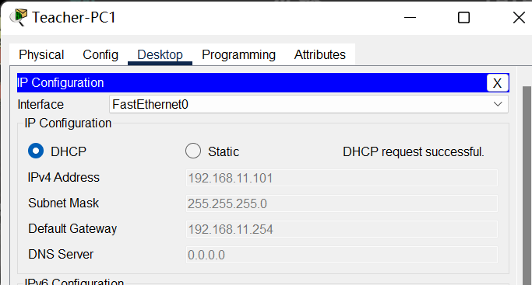

Gatweay-Router1#show ip dhcp binding

IP address Client-ID/ Lease expiration Type

Hardware address

192.168.11.101 0090.0C07.49D3 -- Automatic

192.168.11.102 00D0.FFB7.5D26 -- Automatic

192.168.22.101 00E0.F983.3075 -- Automatic

192.168.22.102 00D0.BAB8.A545 -- Automatic

Step 2 – DHCP Server

3. configure the DHCP pool on the server (e.g. DHCP-Server).

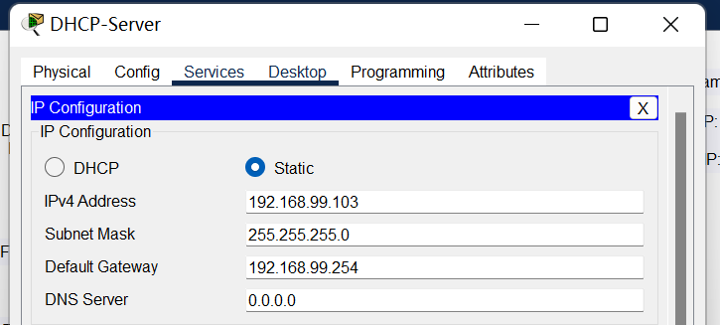

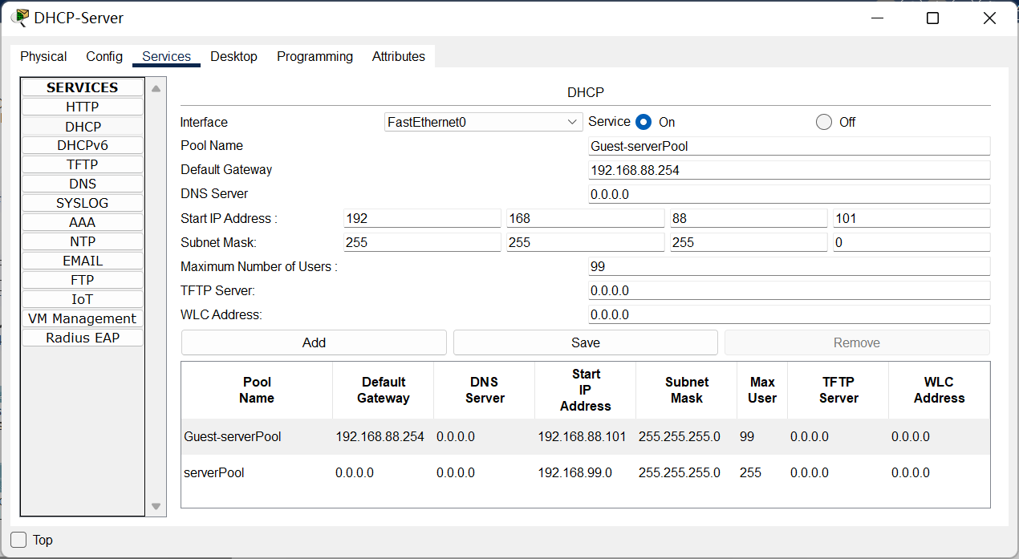

Switch99(config)#int f 0/3

Switch99(config-if)#switchport mode access

Switch99(config-if)#switchport access vlan 99

4. configure the DHCP relay from Laptops to the server (e.g. DHCP-Server).

Reference 4.DHCP.Q25

Switch3(config)#interface vlan 88

Switch3(config-if)#ip helper-address 192.168.99.103

Switch4(config)#interface vlan 88

Switch4(config-if)#ip helper-address 192.168.99.103

**Part 2 – NAT.**

Requirement:

2.1 Internet-PC -> Web-Server/FTP-Server. (Static NAT)

2.2 Teacher-PCs/Student-PCs/Guest-Laptops -> Internet-PC. (Dynamic NAT)

Step 3 – Static NAT

5. configure the static nat for server translation on the border router (Gateway-Router1).

Reference 4.NAT.Q30~31

Gatweay-Router1(config)#ip nat inside source static 192.168.99.101 200.200.123.2

Gatweay-Router1(config)#ip nat inside source static 192.168.99.102 200.200.123.3

Gatweay-Router1(config)#interface range f 0/0-1

Gatweay-Router1(config-if-range)#ip nat inside

Gatweay-Router1(config-if-range)#interface range f 1/0

Gatweay-Router1(config-if-range)#ip nat outside

6. configure the route from border router (Gateway-Router1) to ISP router.

Reference 4.NAT.Q13,16,17;

Reference 4.NAT.Q18,20,21

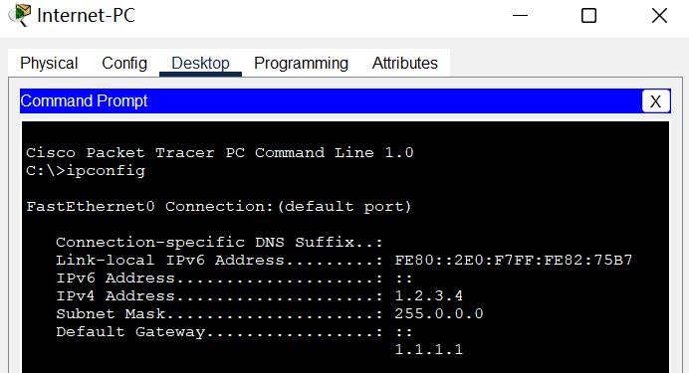

Gatweay-Router1(config)#interface f 1/0

Gatweay-Router1(config-if)#ip address 200.200.200.2 255.255.255.252

Gatweay-Router1(config-if)#no shutdown

ISP-Router(config)#interface f 0/0

ISP-Router(config-if)#ip address 1.1.1.1 255.0.0.0

ISP-Router(config-if)#no shutdown

ISP-Router(config-if)#interface f 1/0

ISP-Router(config-if)#ip address 200.200.200.1 255.255.255.252

ISP-Router(config-if)#no shutdown

Switch3(config)#ip route 0.0.0.0 0.0.0.0 192.168.101.1

Switch4(config)#ip route 0.0.0.0 0.0.0.0 192.168.102.1

Gatweay-Router1(config)#ip route 0.0.0.0 0.0.0.0 200.200.200.1

ISP-Router(config)#ip route 200.200.123.0 255.255.255.248 200.200.200.2

Step 4 – Dynamic NAT

7. configure the dynamic nat for PC translation on the border router (Gateway-Router1).

Reference 4.NAT.Q37~39

Gatweay-Router1(config)#ip access-list standard NAT-List

Gatweay-Router1(config-std-nacl)#permit 192.168.11.0 0.0.0.255

Gatweay-Router1(config-std-nacl)#permit 192.168.22.0 0.0.0.255

Gatweay-Router1(config-std-nacl)#permit 192.168.88.0 0.0.0.255

Gatweay-Router1(config-std-nacl)#exit

Gatweay-Router1(config)#ip nat pool NAT-Pool 200.200.123.1 200.200.123.1 netmask 255.255.255.248

Gatweay-Router1(config)#ip nat inside source list NAT-List pool NAT-Pool overload

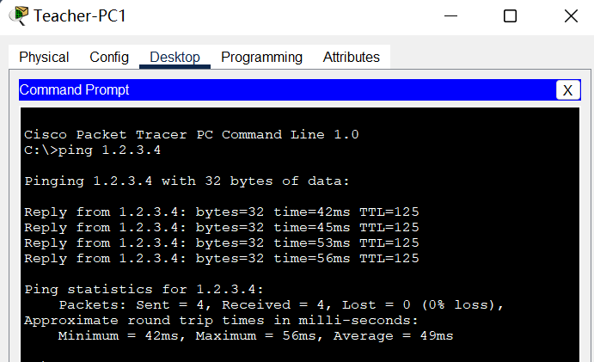

Gatweay-Router1#show ip nat translations

Pro Inside global Inside local Outside local Outside global

icmp 200.200.123.1:1 192.168.11.101:1 1.2.3.4:1 1.2.3.4:1

icmp 200.200.123.1:2 192.168.11.101:2 1.2.3.4:2 1.2.3.4:2

icmp 200.200.123.1:3 192.168.11.101:3 1.2.3.4:3 1.2.3.4:3

icmp 200.200.123.1:4 192.168.11.101:4 1.2.3.4:4 1.2.3.4:4

--- 200.200.123.2 192.168.99.101 --- ---

--- 200.200.123.3 192.168.99.102 --- ---

**Part 3 – IPv6 transition.**

Requirement:

3.1 IPv6-PC -> IPv6-Server. (Tunneling)

3.2 IPv6-PC -> Web-Server/FTP-Server. (NATPT)

Step 5 – IPv6 tunnel

1. configure the ipv6 subnet on the PC site.

IPv6-Router(config)#ipv6 unicast-routing

IPv6-Router(config)#interface f 0/0

IPv6-Router(config-if)#ipv6 address 2001:2345:6789:66::6/64

IPv6-Router(config-if)#no shutdown

IPv6-Router(config-if)#interface f 0/1

IPv6-Router(config-if)#ip address 192.168.66.6 255.255.255.0

IPv6-Router(config-if)#no shutdown

2. configure the ipv6 subnet on the Server site.

Router99(config)#ipv6 unicast-routing

Router99(config)#interface f 0/0

Router99(config-if)#ipv6 address 2001:2345:6789:99::6/64

Router99(config-if)#no shutdown

Router99(config-if)#interface f 0/1

Router99(config-if)#ip address 192.168.99.6 255.255.255.0

Router99(config-if)#no shutdown

3. configure the ipv4 subnets between the PC site and Server site.

Switch3(config)#interface f 0/6

Switch3(config-if)#switchport mode access

Switch3(config-if)#switchport access vlan 66

% Access VLAN does not exist. Creating vlan 66

Switch3(config-if)#interface vlan 66

Switch3(config-if)#ip address 192.168.66.1 255.255.255.0

Switch3(config-if)#no shutdown

Switch3(config-if)#standby 66 ip 192.168.66.254

Switch3(config-if)#standby 66 priority 99

Switch3(config-if)#standby 66 preempt

Switch4(config)#interface vlan 66

Switch4(config-if)#ip address 192.168.66.2 255.255.255.0

Switch4(config-if)#no shutdown

Switch4(config-if)#standby 66 ip 192.168.66.254

Switch4(config-if)#standby 66 priority 101

Switch4(config-if)#standby 66 preempt

Switch99(config)#int f 0/6

Switch99(config-if)#switchport mode access

Switch99(config-if)#switchport access vlan 99

4. configure the ipv6 over ipv4 tunnel between the routers of the PC site and Server site.

Reference 4.tunnel

IPv6-Router(config)#interface tunnel 64

%LINK-5-CHANGED: Interface Tunnel64, changed state to up

IPv6-Router(config-if)#tunnel source f 0/1

IPv6-Router(config-if)#tunnel destination 192.168.99.6

IPv6-Router(config-if)#tunnel mode ipv6ip

IPv6-Router(config-if)#

%LINEPROTO-5-UPDOWN: Line protocol on Interface Tunnel64, changed state to up

IPv6-Router(config-if)#ipv6 address 2001:2345:6789:64::66/64

Router99(config)#interface tunnel 64

Router99(config-if)#tunnel source fastEthernet 0/1

Router99(config-if)#tunnel destination 192.168.66.6

Router99(config-if)#tunnel mode ipv6ip

Router99(config-if)#ipv6 address 2001:2345:6789:64::99/64

5. configure the ipv4 route and ipv4 route between the routers of the PC site and Server site.

IPv6-Router(config)#ip route 192.168.99.0 255.255.255.0 192.168.66.254

IPv6-Router(config)#ipv6 route 2001:2345:6789:99::/64 2001:2345:6789:64::99

Router99(config)#ip route 192.168.66.0 255.255.255.0 192.168.99.254

Router99(config)#ipv6 route 2001:2345:6789:66::/64 2001:2345:6789:64::66

6. test the connectivity of the tunnel between the PC site and Server site.

Step 6 – NAT-PT

11. configure the nat-pt on IPv6-Router.

Reference 4.natpt.Configuration Examples for NAT-PT for IPv6

IPv6-Router(config)#interface f 0/0

IPv6-Router(config-if)#ipv6 nat

IPv6-Router(config-if)#interface f 0/1

IPv6-Router(config-if)#ipv6 nat

IPv6-Router(config)#ipv6 access-list v6List

IPv6-Router(config-ipv6-acl)#permit ipv6 2001:2345:6789:66::/64 2001:2345:6789:99::192.168.99.101/128

IPv6-Router(config-ipv6-acl)#permit ipv6 2001:2345:6789:66::/64 2001:2345:6789:99::192.168.99.102/128

IPv6-Router(config-ipv6-acl)#exit

IPv6-Router(config)#ipv6 nat v6v4 pool v4Pool 192.168.66.101 192.168.66.199 prefix-length 24

IPv6-Router(config)#ipv6 nat v6v4 source list v6List pool v4Pool

IPv6-Router(config)#

IPv6-Router(config)#ipv6 nat prefix 2001:2345:6789:99::/96

IPv6-Router(config)#interface f 0/0

IPv6-Router(config-if)#ipv6 nat prefix 2001:2345:6789:99::/96 v4-mapped v6List

IPv6-Router#show ipv6 nat translations

Prot IPv4 source IPv6 source

IPv4 destination IPv6 destination

icmp 192.168.66.102,10 2001:2345:6789:66:260:70FF:FE4C:7D9B,10

192.168.99.102,10 2001:2345:6789:99::C0A8:6366,10

icmp 192.168.66.102,11 2001:2345:6789:66:260:70FF:FE4C:7D9B,11

192.168.99.102,11 2001:2345:6789:99::C0A8:6366,11

icmp 192.168.66.102,12 2001:2345:6789:66:260:70FF:FE4C:7D9B,12

192.168.99.102,12 2001:2345:6789:99::C0A8:6366,12

icmp 192.168.66.102,9 2001:2345:6789:66:260:70FF:FE4C:7D9B,9

192.168.99.102,9 2001:2345:6789:99::C0A8:6366,9

--- 192.168.66.101 2001:2345:6789:66:2D0:D3FF:FE8B:BC64

--- --- ---

--- 192.168.66.102 2001:2345:6789:66:260:70FF:FE4C:7D9B ---